DISCOVER MICHIGAN’S CREATIVE COAST
Michigan’s Creative Coast is a one-stop relocation resource for everything you need to live, fulfill your career, and get connected in the Grand Traverse Region. The Traverse City area is home to a diverse and impressive array of career opportunities in technology, trade industries, and the creative sectors, offering growth opportunities in small and medium-sized businesses. The Region is also desirable for remote workers, offering a number of shared workspaces and cohort groups.
Michigan’s Creative Coast Homepage Button
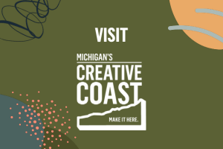

CONNECT WITH A NORTHERN NAVIGATOR
Thinking of making the move but want to know more about what it’s like to live here? Connect with a Northern Navigator! Acting as ‘regional ambassadors’, Northern Navigators are people who already live here, who have chosen to live here, and who can help you as a newcomer (or potential newcomer) feel welcomed and connected, all while offering knowledge of the regional lifestyle, recreation, schools, healthcare, real estate, and industry and career opportunities.
Northern Navigators Button
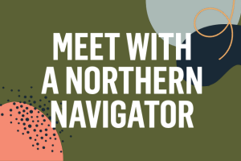
And finally – we suggest you add our 2-min talent attraction video “Make It Here” to your careers page. The video invites the viewer to imagine their life in the Grand Traverse Region. Just visit the video link and then click the paper airplane icon on the video and select the < /> icon to get the video embed code for your website.

