DISCOVER MICHIGAN’S CREATIVE COAST
Michigan’s Creative Coast is a one-stop relocation resource for everything you need to live, fulfill your career, and get connected in the Grand Traverse Region. The Traverse City area is home to a diverse and impressive array of career opportunities in technology, trade industries, and the creative sectors, offering growth opportunities in small and medium-sized businesses. The Region is also desirable for remote workers, offering a number of shared workspaces and cohort groups.
Michigan’s Creative Coast Homepage Button
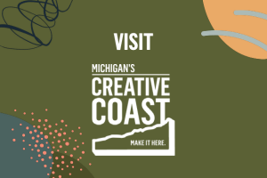

CONNECT WITH A NORTHERN NAVIGATOR
Considering a move to the Traverse City area? Maybe you’ve recently moved here and you want to get plugged into a network and the community? Northern Navigators are here to help. Acting as ‘regional ambassadors’, Northern Navigators are people who already live here, who have chosen to live here, and who can help you as a newcomer feel welcomed and connected, all while offering knowledge of the regional lifestyle, recreation, schools, healthcare, real estate, and industry and career opportunities. Connect now with a Northern Navigator.
Northern Navigators Button
